ASSIGNMENT SUBMISSION COVER SHEET

Student Id: cse25-205

Student names: Lone Miso Kufuna
cse25-205@thuto.bac.ac.bw
Student email:

Cohort: cse25

Assignment title: BANKING SYSTEM REQUIREMENTS ELICITATION

Date of submission: 23 October 2026
Programme of Study: Computer Systems Engineering
Year of Study: 2025

Intellectual property statement
By checking the box below, I certify that this assignment is my own work and is free from plagiarism. I understand that the assignment may be checked for plagiarism by electronic or other means and may be transferred and stored in a database for the purposes of data-matching to help detect plagiarism. The assignment has not previously been submitted for assessment in any other unit or to any other institution. I have read and understood the Botswana Accountancy College plagiarism guidelines policy.



Agree Signature:

REQUIREMENTS ELICITATION

Functional Requirements

1. The system shall register customers as individuals or organisations.
- For individuals, it shall capture first name, surname, ID number, address and contact details.
- For organisations, it shall capture organisation name, registration number, registration date, address, contact details and a contact person.

2. The system shall authenticate users using a valid username and password before granting access to protected features.
3. The system shall allow registered customers to open Savings, Investment or Cheque accounts, subject to the eligibility rules for the selected account type.
4. The system shall link every account to exactly one customer and allow each customer to hold multiple accounts, including more than one account of the same type and accounts of different types where eligible.
5. The system shall reject all withdrawal requests from Savings accounts.
6. The system shall open an Investment account only when the initial deposit is at least BWP500.00.
7. The system shall open a Cheque account only for an employed individual customer and shall capture the employer’s name and address.
8. The system shall allow customers to deposit a positive amount into any account they hold.
9. The system shall allow customers to withdraw a positive amount from Investment and Cheque accounts they hold, provided the balance is sufficient.
10. The system shall reject transaction requests containing invalid or missing amounts, zero or negative amounts, insufficient funds, or attempts to transact on another customer’s account, and shall display an appropriate error message.
11. The system shall automatically calculate and credit monthly interest at 0.05% for Savings accounts and 5% for Investment accounts.
12. The system shall record successful deposits, withdrawals and interest credits and allow customers to view their transaction history, including date/time, transaction type, amount and resulting balance.
13. The system shall display the authenticated customer’s accounts, account types and current balances.
14. The system shall prevent interest from being credited more than once to the same account for the same month.
15. The system shall save customer, account, transaction and interest payment records to the database and retrieve them when required.
16. The system shall generate a unique account number for each new account.
17. The system shall reject login attempts with missing or invalid credentials and display a generic error message that does not reveal which detail was wrong.
18. The system shall allow customers to log out, ending their session.
19. The system shall reject a registration if a required detail is missing, or if the username, ID number or registration number is already in use, and shall display an appropriate error message.
20. The system shall record a failed interest payment and retry it at the next interest run.

Non-Functional Requirements

1. Security
  - Passwords shall not be stored as plain text, and password-entry fields shall mask entered characters.
  - The system shall restrict customers to viewing and transacting on their own accounts only.
  - The system shall end a session after 5 minutes of inactivity.

- Performance
- Under normal load, transactions shall complete in under 2 seconds and login in under 3 seconds.
- The system shall support at least 10 concurrent users without errors.

- Usability
- JavaFX screens shall use consistent labels, navigation and button styles.
- Validation messages shall identify the problem and explain how to correct it.

- Reliability and Integrity
- Each transaction shall be atomic: it completes fully or not at all.
  - The system shall not allow a withdrawal to make a balance negative.
  - The system shall not lose stored data when the application closes.

- Maintainability
- The application shall separate views, controllers, domain classes and DAO classes.
- It shall demonstrate the required OOP principles, use meaningful names and document non-obvious logic.
- Source code shall be version-controlled using Git.

6. Scalability
- The design should support growth in the number of individual customers, organisations, accounts and transactions.

7. Monetary precision
- Monetary values shall use a decimal representation and posted amounts and balances shall use two decimal places under an agreed rounding policy.

8. Compatibility
- The application shall build and run in the agreed Java environment, use JavaFX for its GUI and connect to the selected database through JDBC. The repository shall document the required versions and setup steps.

Appendix A: Mock Client Interview Record

- Interview date:
- Interviewer: Lone Kufuna
- Interviewee: Kentsenao Baseki
- Role: lecturer/tutor acting as the client
- Purpose: identify and clarify banking-system functions, business rules and quality expectations

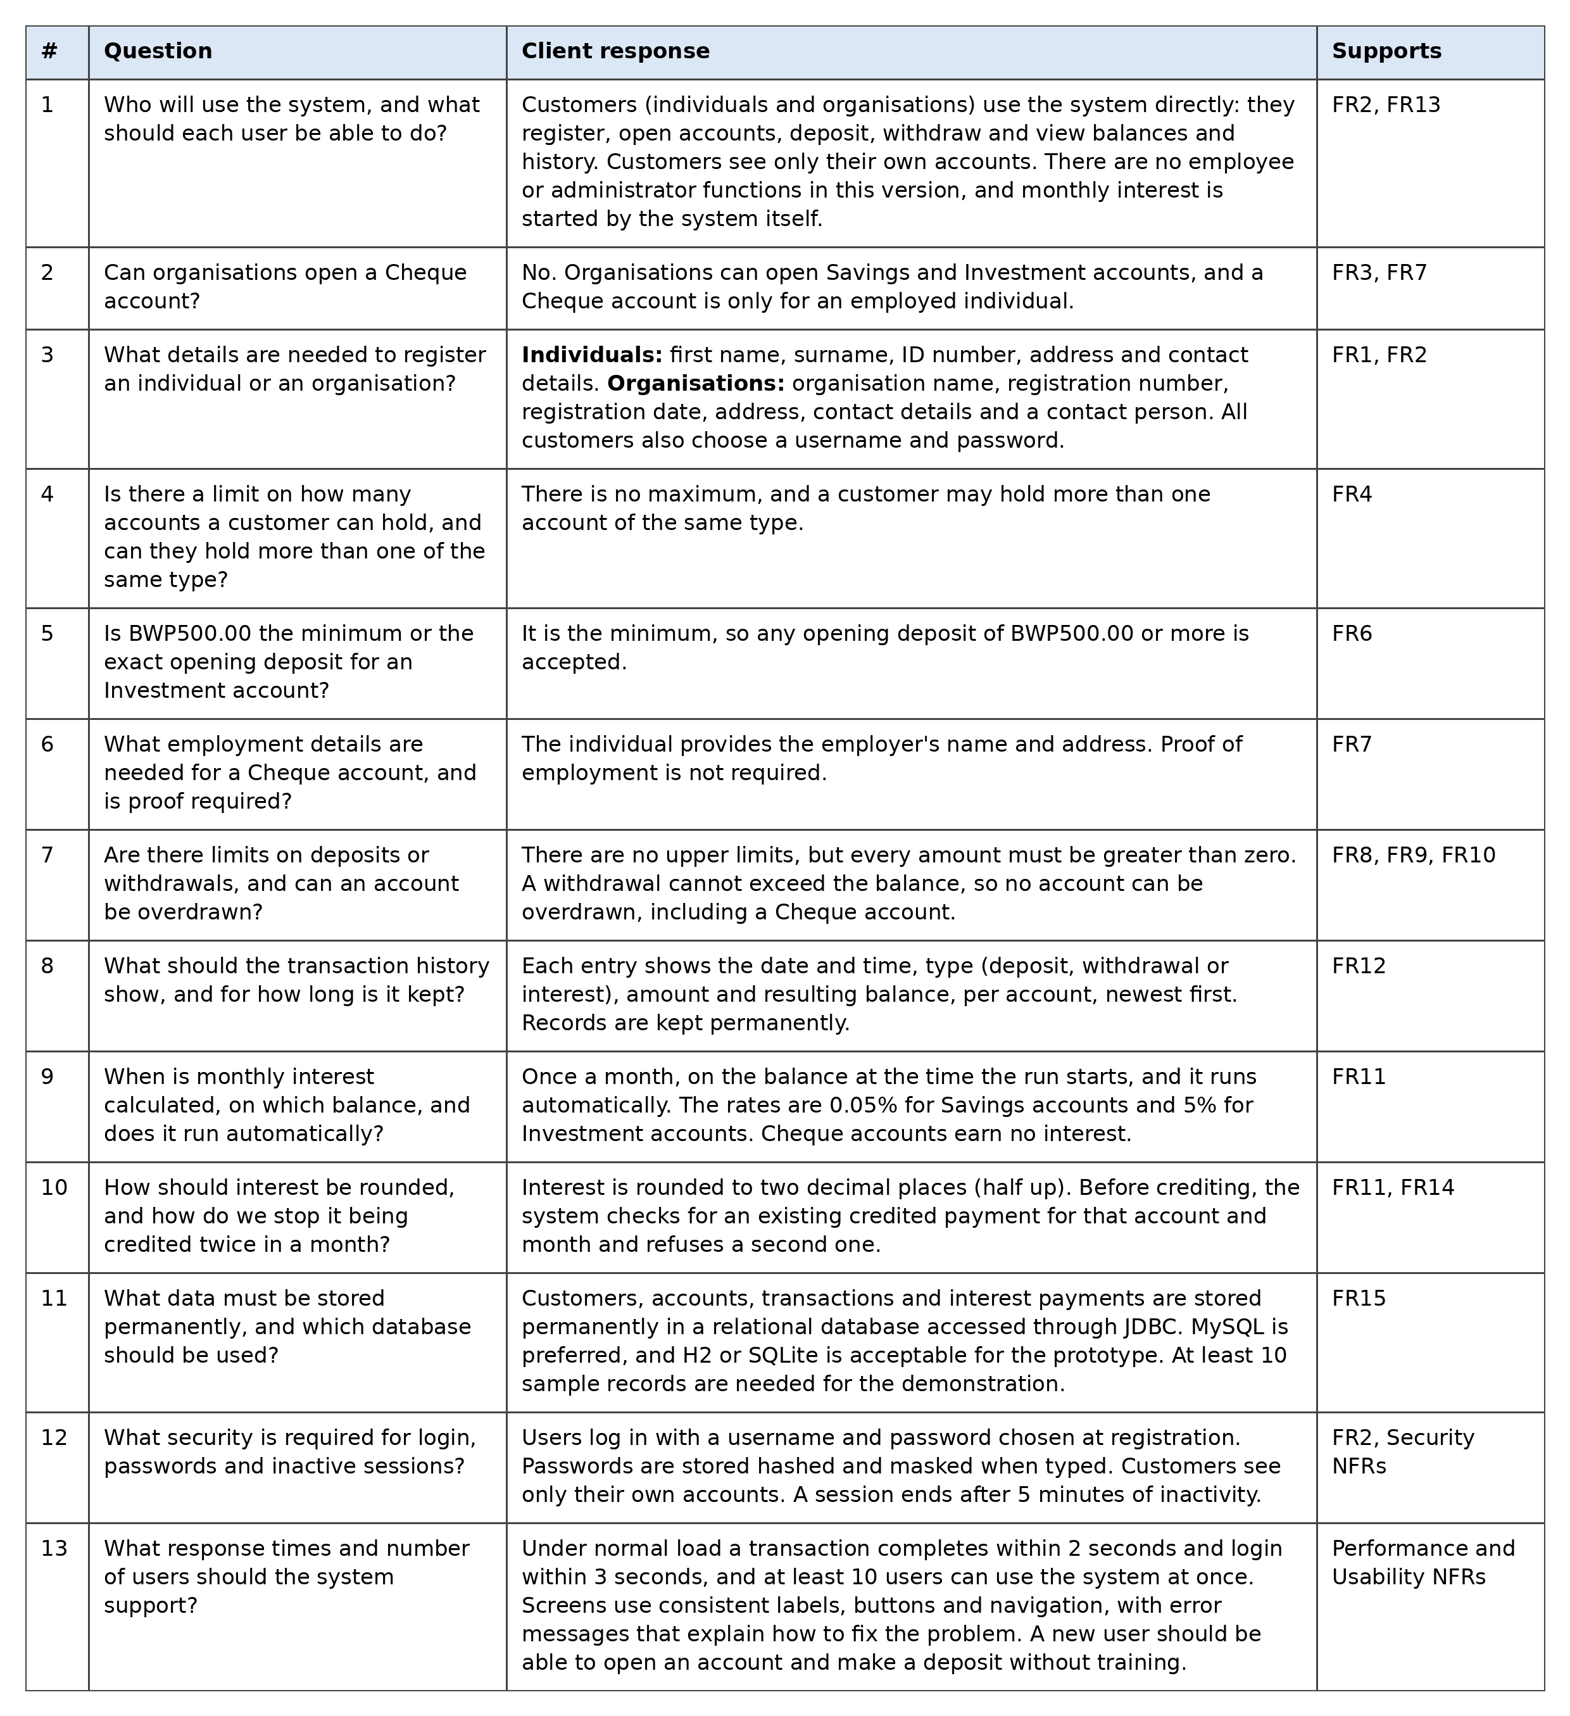
Use Case Diagram

- Shows the interactions between the Customer, System Scheduler, and Banking system.
- Customers can register, open accounts, view balances and transaction history, deposit funds, and withdraw funds.
- The system validates requests, enforces login requirements, and records transactions.
- The System Scheduler initiates monthly interest payments automatically.

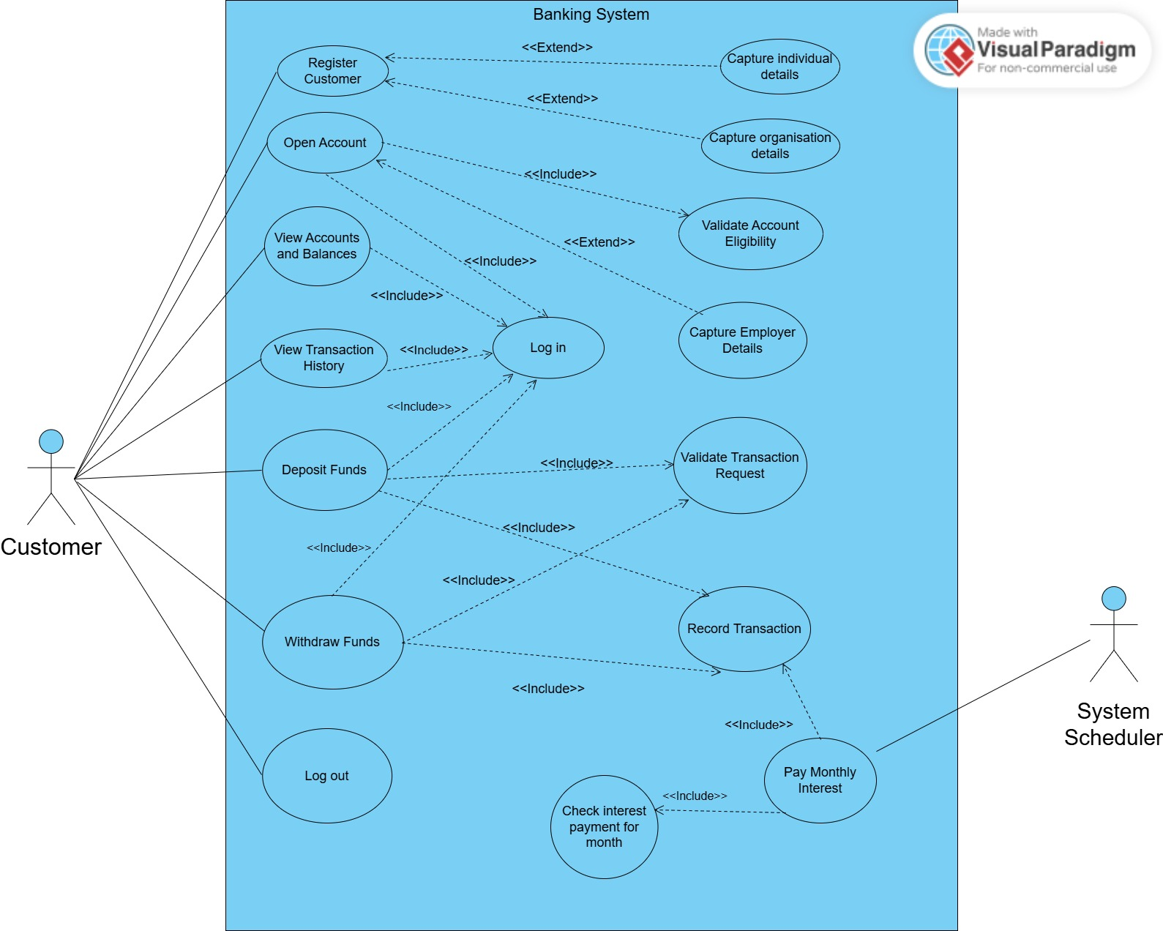

Class Diagram

- Shows the system's structure, including customers, accounts, transactions, and interest payments.
- Abstract classes and inheritance support individual and organisation customers, as well as the different account types.
- Interfaces define interest-bearing and withdrawable behaviour, while enumerations represent transaction types and payment statuses.

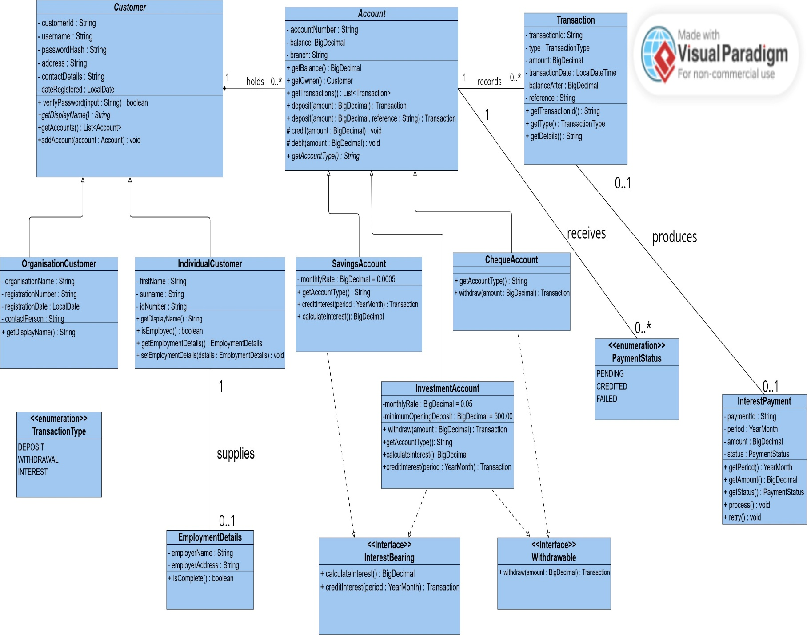

Sequence diagram – Log in
- Shows how a customer logs in through the LoginView and LoginController.
- CustomerDAO retrieves the customer from the database, and the customer's password is verified.
- Successful authentication opens the dashboard, while invalid credentials produce a generic error message.

The login sequence has no separate authentication service. The Customer class checks the password itself through verifyPassword(), because it holds the private password hash. LoginController coordinates the flow, so a separate service would only pass calls along without adding any behaviour.
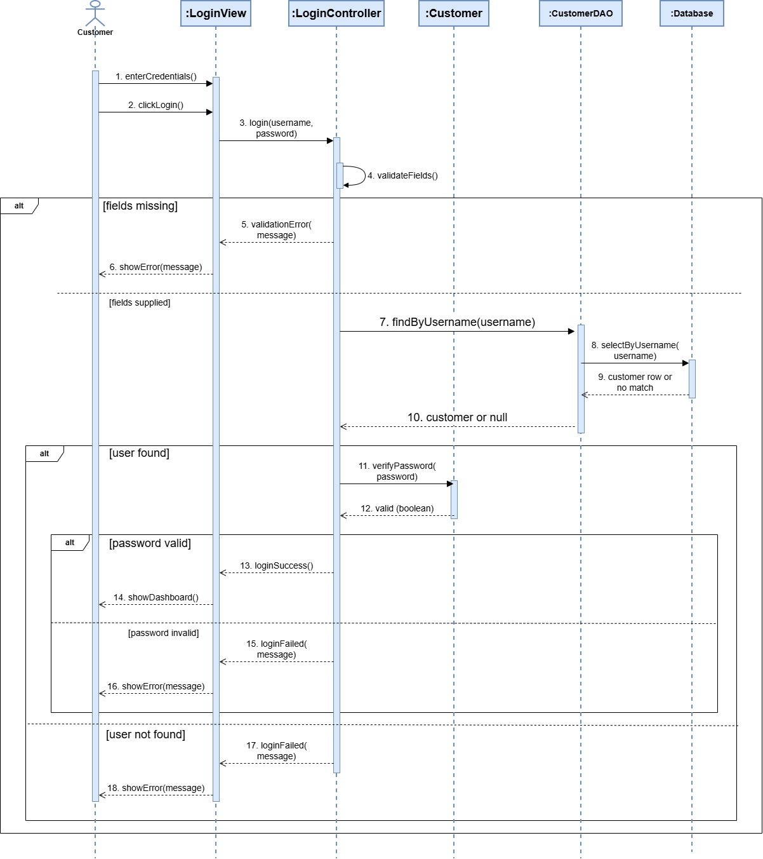
Sequence Diagram – deposit funds
- Shows how a deposit request is validated and processed after the customer logs in.
- AccountDAO retrieves the account, and the controller checks account ownership before calling deposit() on the Account.
- The account balance and transaction are saved, and the updated balance is displayed.
- Invalid requests or failed saves produce an error message.

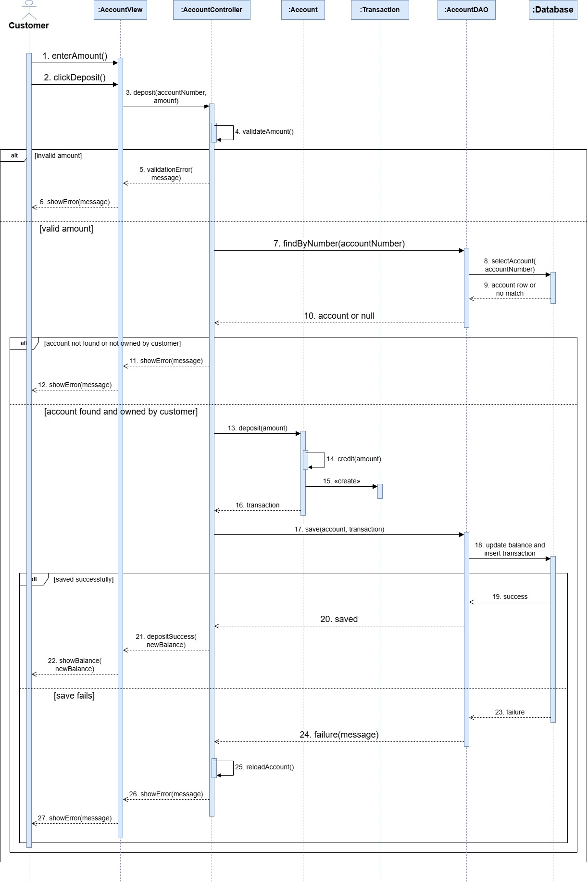
State Machine Diagram
- Shows the possible states of a monthly interest payment: PENDING, CREDITED, and FAILED.
- Successful processing credits eligible accounts and records the transaction, while failures result in FAILED.
- A failed payment can be retried, provided the account has not already received interest for that month.
